**Lab Report No: 04**

**Name of the lab report:** File operation and permission.

**Objective:** The file system is the most obvious aspect of any OS. This provides users the method for storage and access to data as well as programs of the operating system. In this report paper we know a lot about File operating process on Linux OS.

**Q.1 What is File Operation and File Permission in Linux Operating System?**

**Answer:**

**As you know that files are used to store the required information for its later uses.** Just likelyin Linux operating system, everything is organized in the form of files and directories. By setting permissions on files and directories, one can make sure that only authorized users are allowed to access a specific data. Each file in Linux is owned by a user and group. The user is the one who creates the file and group is the one to which the user belongs to.

Understand file permission

File permissions consist of three permissions that you can apply to files and directories. In this section, you’ll learn how the system works and how to modify these permissions. Before doing this, let’s have a look at how to read the current permissions. The best method to do so is by using ls-l which will show you a list of all files and directories in the current directory.

For example:

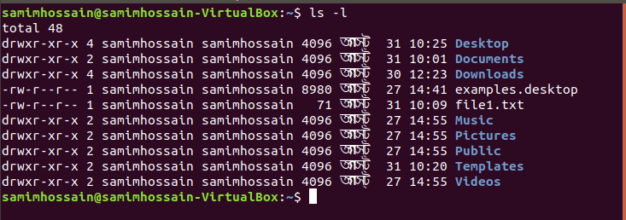

Above this image

the first column shows the file permissions.

the third column shows the user owner of the file.

the fourth column shows the group owner of the file.

**Q2. Implementation of File Operation and File Permission.**

**Answer:**

Numerous on-disk and in-memory configurations and structures are being used for implementing a file system. These structures differ based on the operating system and the file system but applying some general principles. Here they are portrayed below:

* A boot control block usually contains the information required by the system for booting an operating system from that volume. When the disks do not contain any operating system, this block can be treated as empty. This is typically the first chunk of a volume. In UFS, this is termed as the boot block; in NTFS, it is the partition boot sector.
* A volume control block holds volume or the partition details, such as the number of blocks in the partition, size of the blocks or chunks, free-block count along with free-block pointers. In UFS, it is termed as superblock; in NTFS, it is stored in the master file table.
* A directory structure per file system is required for organizing the files. In UFS, it held the file names and associated 'inode' numbers. In NTFS, it gets stored in the master file table.
* The FCB contains many details regarding any file which includes file permissions, ownership; the size of file and location of data blocks. In UFS, it is called the inode. In NTFS, this information gets stored within the master file table that uses a relational database (RDBM) structure, using a row per file.

Permission Groups

Each file and directory has three user based permission groups:

Owner: The Owner permissions apply only the owner of the file or directory, they will not impact the actions of other users.

Group: The Group permissions apply only to the group that has been assigned to the file or directory, they will not effect the actions of other users.

All user: The All Users permissions apply to all other users on the system, this is the permission group that you want to watch the most.

Permission Types

Each file or directory has three basic permission types:

Read: The Read permission refers to a user’s capability to read the contents of the file.

Write: The Write permissions refer to a user’s capability to write or modify a file or directory.

Execute: The Execute permission affects a user’s capability to execute a file or view the contents of a directory.

**Conclusion:**

File Management. Some operating systems offer access to hardware through file management. Linux, which is part of Android OS is an example. So in Android, you can't make anything useful without it. It's also possible to make an operating system without files. It's valid to treat a disk as if it is just a big block of memory.